Logic Gates.

Logic gates are the basic building blocks of any digital system. It is an electronic circuit having one or more than one input and only one output. The relationship between the input and the output is based on a **certain logic**. Based on this, logic gates are named as AND gate, OR gate, NOT gate etc.

AND Gate

A circuit which performs an AND operation is shown in figure. It has n input (n >= 2) and one output.

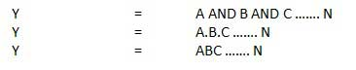

Logic diagram

### AND Logical DiagramTruth Table

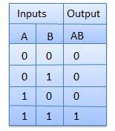

OR Gate

A circuit which performs an OR operation is shown in figure. It has n input (n >= 2) and one output.

OR gate

Logic diagram

OR Logical Diagram

Truth Table

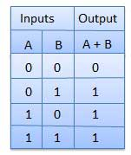

NOT Gate

NOT gate is also known as **Inverter**. It has one input A and one output Y.

NOT gate

Logic diagram

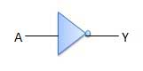

Truth Table

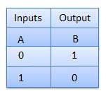

NAND Gate

A NOT-AND operation is known as NAND operation. It has n input (n >= 2) and one output.

NAND gate

Logic diagram

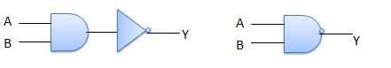

Truth Table

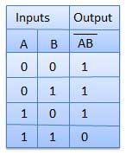

NOR Gate

A NOT-OR operation is known as NOR operation. It has n input (n >= 2) and one output.

NOR gate

Logic diagram

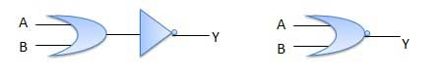

Truth Table

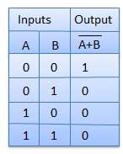

XOR Gate ( Exclusive OR gate)

XOR or Ex-OR gate is a special type of gate. It can be used in the half adder, full adder and subtractor. The exclusive-OR gate is abbreviated as EX-OR gate or sometime as X-OR gate. It has n input (n >= 2) and one output.

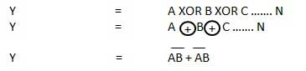

Logic diagram

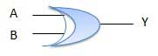

Truth Table

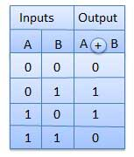

XNOR Gate

XNOR gate is a special type of gate. It can be used in the half adder, full adder and subtractor. The exclusive-NOR gate is abbreviated as EX-NOR gate or sometime as X-NOR gate. It has n input (n >= 2) and one output.

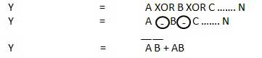

Logic diagram

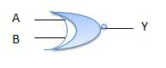

Truth Table

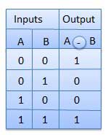

**BOOLEAN ALGEBRA**

**Boolean Algebra** is an algebra, which deals with binary numbers & binary variables. Hence, it is also called as Binary Algebra or logical Algebra. A mathematician, named George Boole had developed this algebra in 1854. The variables used in this algebra are also called as Boolean variables.

The range of voltages corresponding to Logic ‘High’ is represented with ‘1’ and the range of voltages corresponding to logic ‘Low’ is represented with ‘0’.

Postulates and Basic Laws of Boolean Algebra

In this section, let us discuss about the Boolean postulates and basic laws that are used in Boolean algebra. These are useful in minimizing Boolean functions.

Boolean Postulates(Set of Rules)

Consider the binary numbers 0 and 1, Boolean variable x and its complement x′. Either the Boolean variable or complement of it is known as **literal**. The four possible **logical OR** operations among these literals and binary numbers are shown below.

x + 0 = x

x + 1 = 1

x + x = x

x + x’ = 1

Similarly, the four possible **logical AND** operations among those literals and binary numbers are shown below.

x.1 = x

x.0 = 0

x.x = x

x.x’ = 0

These are the simple Boolean postulates. We can verify these postulates easily, by substituting the Boolean variable with ‘0’ or ‘1’.

**Note**− The complement of complement of any Boolean variable is equal to the variable itself. i.e., x′x′’=x.

Basic Laws of Boolean Algebra

Following are the three basic laws of Boolean Algebra.

* Commutative law
* Associative law
* Distributive law

Commutative Law

If any logical operation of two Boolean variables give the same result irrespective of the order of those two variables, then that logical operation is said to be **Commutative**. The logical OR & logical AND operations of two Boolean variables x & y are shown below

x + y = y + x (for addition)

x.y = y.x ( for multiplication)

The symbol ‘+’ indicates logical OR operation. Similarly, the symbol ‘.’ indicates logical AND operation and it is optional to represent. Commutative law obeys for logical OR & logical AND operations.

Associative Law

If a logical operation of any two Boolean variables is performed first and then the same operation is performed with the remaining variable gives the same result, then that logical operation is said to be **Associative**. The logical OR & logical AND operations of three Boolean variables x, y & z are shown below.

(x+y )+z = x+ ( y+z) (for addition)

x.y .z = x. y.z ( for multiplication)

Associative law obeys for logical OR & logical AND operations.

Distributive Law

If any logical operation can be distributed to all the terms present in the Boolean function, then that logical operation is said to be **Distributive**. The distribution of logical OR & logical AND operations of three Boolean variables x, y & z are shown below.

Distributive law obeys for logical OR and logical AND operations.

x. y +z = x .y + x. z

x+ y .z = x + y . x+ z

These are the Basic laws of Boolean algebra. We can verify these laws easily, by substituting the Boolean variables with ‘0’ or ‘1’.

Theorems of Boolean Algebra

The following two theorems are used in Boolean algebra.

* Duality theorem
* De Morgan’s theorem

Duality Theorem

This theorem states that the **dual** of the Boolean function is obtained by interchanging the logical AND operator with logical OR operator and zeros with ones. For every Boolean function, there will be a corresponding Dual function.

Let us make the Boolean equations relations  that we discussed in the section of Boolean postulates and basic laws into two groups. The following table shows these two groups.

|  |  |
| --- | --- |
| **Group1** | **Group2** |
| x + 0 = x | x.1 = x |
| x + 1 = 1 | x.0 = 0 |
| x + x = x | x.x = x |
| x + x’ = 1 | x.x’ = 0 |
| x + y = y + x | x.y = y.x |
|  |  |
|  |  |

In each row, there are two Boolean equations and they are dual to each other. We can verify all these Boolean equations of Group1 and Group2 by using duality theorem.

De Morgan’s Theorem

This theorem is useful in finding the **complement of Boolean function**. It states that the complement of logical OR of at least two Boolean variables is equal to the logical AND of each complemented variable.

De Morgan’s theorem with 2 Boolean variables x and y can be represented as

(x + y)’ = x’ . y’

OR

( X +y ) = x . y

The dual of the above Boolean function is

(x . y)’ = x’ + y’

Therefore, the complement of logical AND of two Boolean variables is equal to the logical OR of each complemented variable. Similarly, we can apply De Morgan’s theorem for more than 2 Boolean variables also.

Simplification of Boolean Functions.